**Information about the documents of its own sample of Civil Aviation Academy**

Full official name of the university in three languages (Kazakh, Russian, English):

**Азаматтық авиация академиясы**

**Академия гражданской авиации**

**Civil Aviation Academy**

  
**Bachelor`s degree with honors and usual sample**  
(hard cover and insert, size A5)

Publication type - form (insert) with a hard cover.  
The unfolded hardcover format is 224 * 160 mm.

**Master`s degree**  
(hard cover and insert, size A4)  
The unfolded hardcover format is 307 * 220 mm.



5. Materials for the production of the cover: paper for the endpaper - offset, with a density of 120 g / m2.  
Bumvinyl for the cover – red, dark blue and dark red.

6. Cover design: the academy logo is located at the top of the cover.  
Under the logo is the name of the document in the state language - "Diploma",  
The academy logo and the title of the document on the cover are hot-stamped in gold foil. The hard cover is made with a webbing.

**Front side**

Full name of the academy in the state language.

Academy logo image.

The name of the document in the state language.

**Bachelor`s degree with honors and usual sample**  
(front side, size A5)  
Unfolded blank format - 210 * 150 mm, double-sided printing.

*Bachelor`s degree with honors (obverse).*

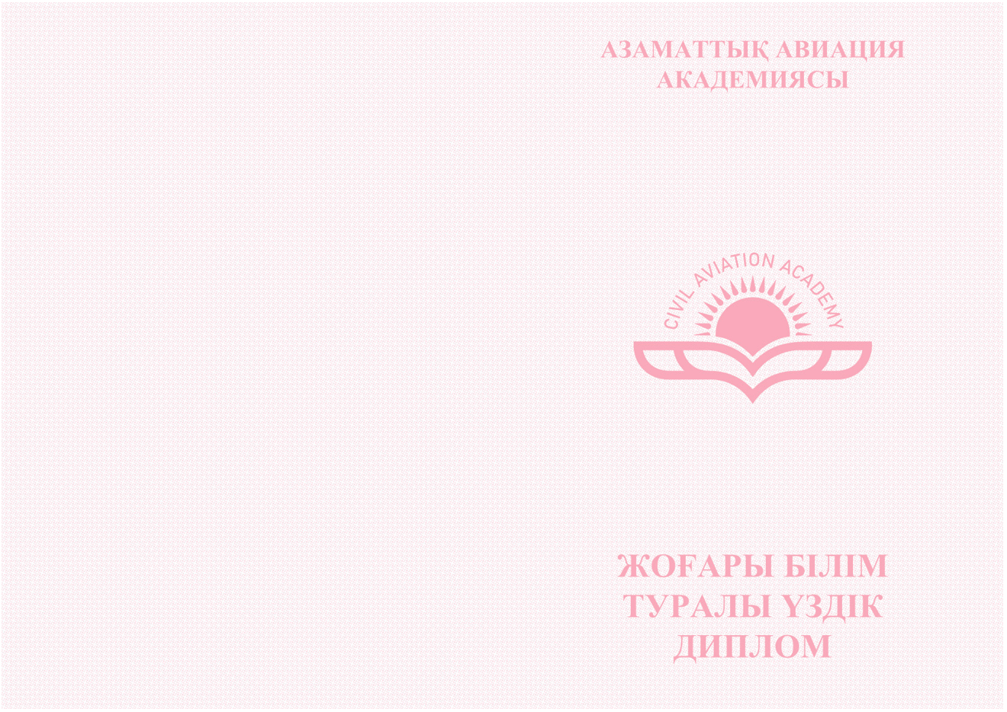

*Regular bachelor`s degree (obverse).*



**Master`s degree**  
(front side, size A4)  
The format of the unfolded form is 297 * 210 mm, double-sided printing.

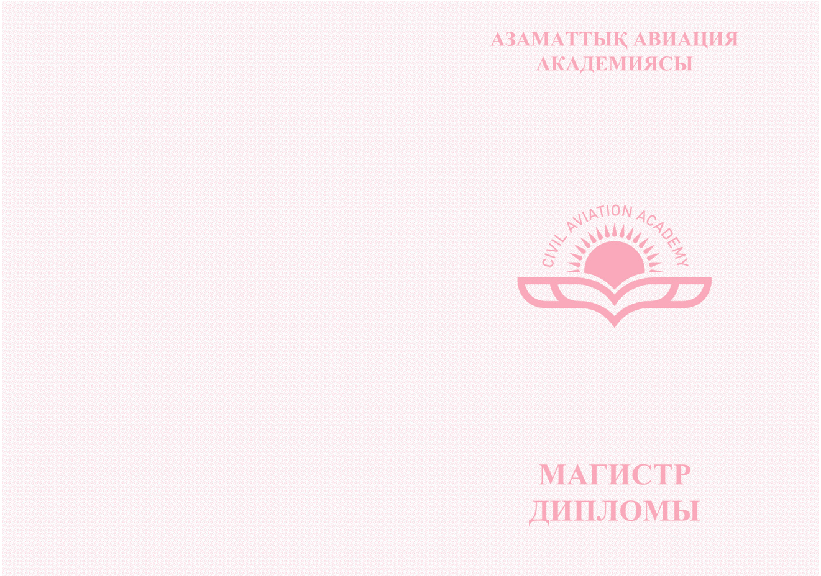

**REVERSE SIDE:**  
Numbering - eleven-digit,  
Series - BD (bachelor) and MD. (Master)  
QR-code, which contains a link to the diploma verification page.  
The invisible seal is the logo of the academy.

**Bachelor`s degree with honors and usual sample**  
(reverse side, size A5)  
Unfolded blank format - 210 * 150 mm, double-sided printing.  
(reverse side, size A5)

*Bachelor`s degree with honors (in Kazakh,Russian and English).*

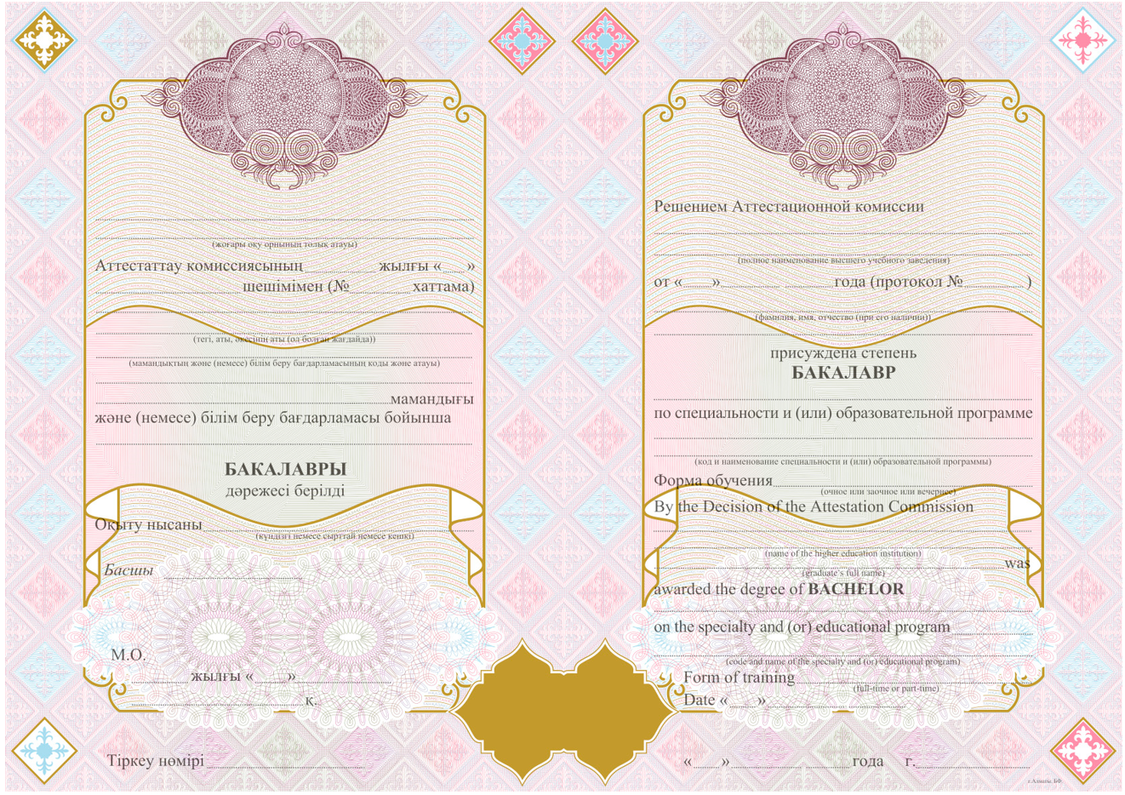

**QR-code**

*Regular bachelor`s degree diploma (in Kazakh, Russian and English ).*

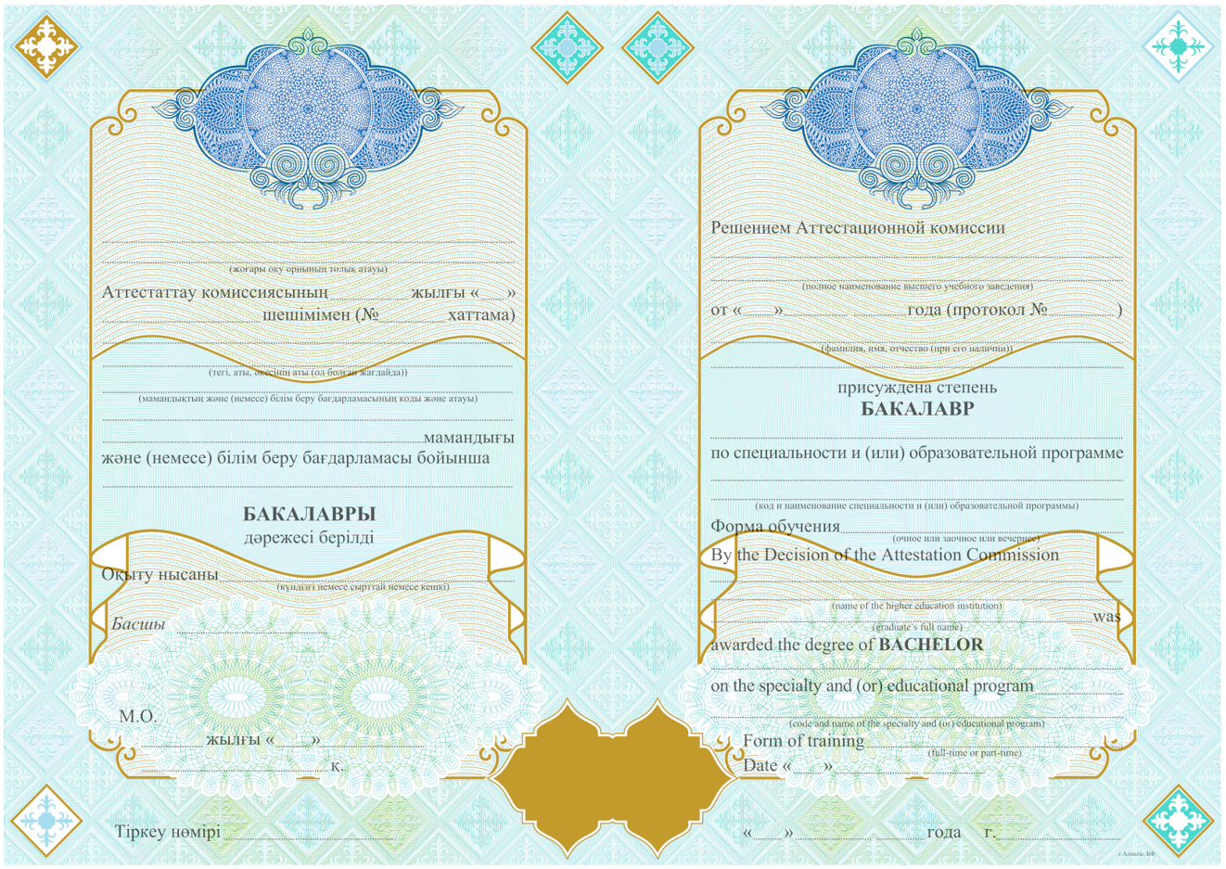

**QR-code**

***Master`s degree*** *(reverse side, size A4)  
The format of the unfolded form is 297 * 210 mm, double-sided printing.*

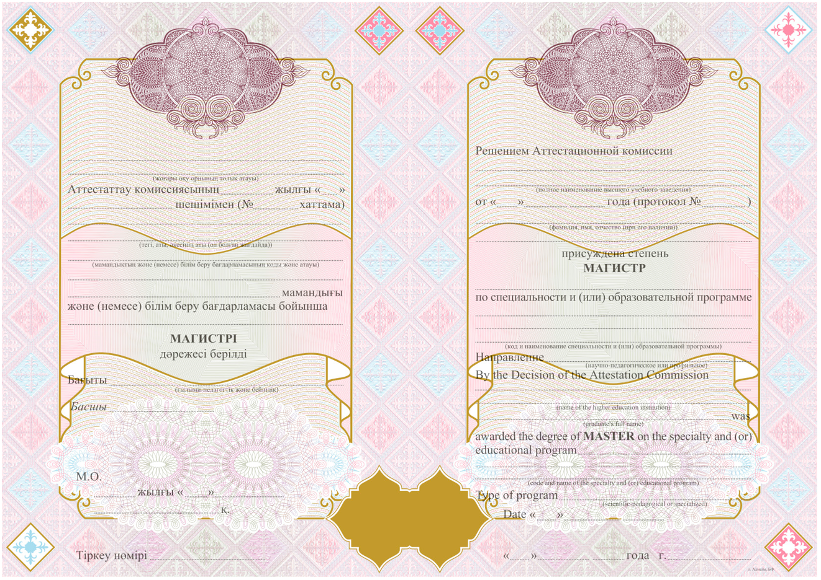

**QR code**